RK UNIVERSITY
School Of Engineering (SEP. – 2025) Semester – 5

Date: 9-9-2025 Branch: CE/IT
Subject Name: Enterprise Computing through .NET Framework Subject code: CE535

Answer Sheet

Division: CE - C Exam Time: 2:25 – 4:15 PM SET: DEMO
Enrollment No: 24SOECE13901 Name: Saurav Pandit Roll No: 54
----------------------------------------------------------------------------------------------------------------------------------

Instructions to Candidates:
- Please fill Division, Exam Time, Set of Paper, Enrollment No., Name & Roll No.
- You will save this file & upload your saved file with the file name is {rollno_enrollmentNo_name_Answersheet}.

This assessment is intended to test the hands on skills related C# Programming.

You must take screenshot of output and write code of each task solution.

Both screenshot and code (each task solution) must contain your Enrollment and Name.

Task_1  Ans. | using System;  using System.Collections.Generic;  using System.Linq;  using System.Text;  using System.Threading.Tasks;  namespace _24SOECE13901_Saurav_Pandit_DEMO_TEST  {  internal class Q1  {  public static void Main(string[] args)  {  for (int i =5; i >= 1; i--)  {  for (int j = 1; j <= i; j++)  {  Console.Write("* ");  }  Console.WriteLine();  }  }  }  }  Output :  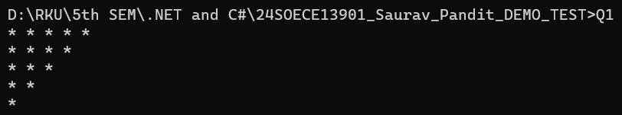
Task_2  Ans. | using System;  using System.Collections.Generic;  using System.Linq;  using System.Text;  using System.Threading.Tasks;  namespace _24SOECE13901_Saurav_Pandit_DEMO_TEST  {  internal class Q2  {  public static void Main(string[] args)  {  Console.Write("Enter the number of elements: ");  int n = Convert.ToInt32(Console.ReadLine());  int[] arr = new int[n];  Console.WriteLine("Enter the elements:");  for (int i = 0; i < n; i++)  {  arr[i] = Convert.ToInt32(Console.ReadLine());  }  Console.WriteLine("\nOriginal Array:");  for (int i = 0; i < n; i++)  {  Console.Write(arr[i] + " ");  }  // reverse order (without using built-in functions)  Console.WriteLine("\n\nArray in Reverse Order:");  for (int i = n - 1; i >= 0; i--)  {  Console.Write(arr[i] + " ");  }  }  }  }  Output :  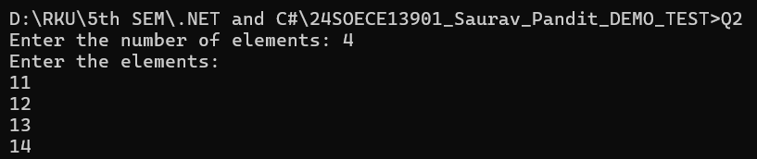
Task_3  Ans. | using System;  using System.Collections.Generic;  using System.Linq;  using System.Text;  using System.Threading.Tasks;  namespace _24SOECE13901_Saurav_Pandit_DEMO_TEST  {  class Employee  {  public int id;  public string name;  public double salary;  public void Display()  {  Console.WriteLine("ID is : " + id);  Console.WriteLine("Name is : " + name);  Console.WriteLine("Salary is : " + salary);  Console.WriteLine("------------------------------");  }  }  internal class Q3  {  public static void Main(string[] args)  {  Employee emp = new Employee();  emp.id = 101;  emp.name = "Saurav";  emp.salary = 25000.00;  emp.Display();  Employee em = new Employee();  em.id = 102;  em.name = "Shubham";  em.salary = 350000;  em.Display();  }  }  }  Output :  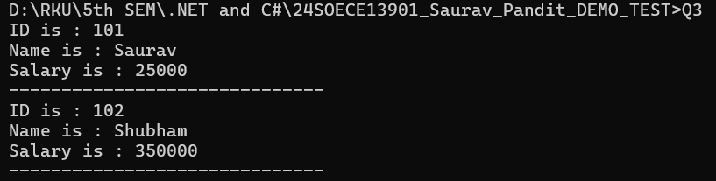
Task_4  Ans. | using System;  using System.Collections.Generic;  using System.ComponentModel;  using System.Data;  using System.Data.SqlClient;  using System.Drawing;  using System.Linq;  using System.Text;  using System.Threading.Tasks;  using System.Windows.Forms;  using static System.Windows.Forms.VisualStyles.VisualStyleElement;  namespace _24SOECE13901_Saurav_Pandit_DEMO_TEST__Windoes_Form_  {  public partial class Form1 : Form  {  string connectionstring = "Data Source=(localdb)\\MSSQLLocalDB;Initial Catalog=demo;Integrated Security=True;Connect Timeout=30;Encrypt=False;Trusted_Connection = True";  public Form1()  {  InitializeComponent();  }  private void button1_Click(object sender, EventArgs e)  {  SqlConnection con = new SqlConnection(connectionstring);  con.Open();  string query = "insert into str values('" + textBox1.Text + "','" + textBox2.Text + "','" + textBox3.Text + "')";  SqlCommand cmd = new SqlCommand(query, con);  cmd.ExecuteNonQuery();  con.Close();  MessageBox.Show("Register Successfully");  }  }  }  Output :  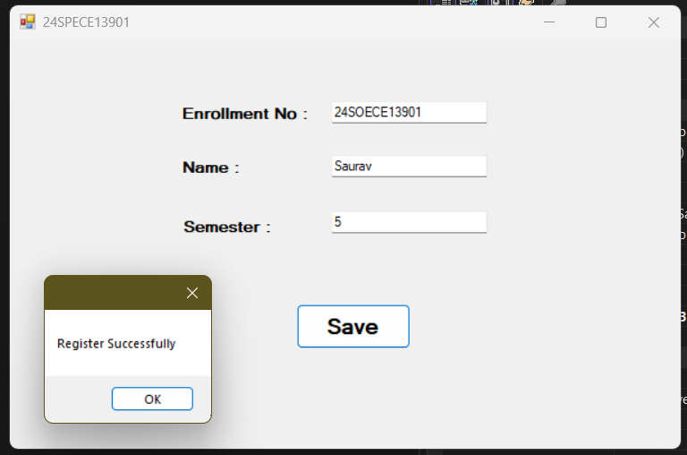
Task_5  Ans. | using System;  using System.Collections.Generic;  using System.ComponentModel;  using System.Data;  using System.Drawing;  using System.Linq;  using System.Text;  using System.Threading.Tasks;  using System.Windows.Forms;  namespace _24SOECE13901_Saurav_Pandit_DEMO_TEST__Windoes_Form_  {  public partial class Form2 : Form  {  public Form2()  {  InitializeComponent();  }  private void btn_sort_Click(object sender, EventArgs e)  {  listBox1.Sorted = true;  }  private void btn_fill_Click(object sender, EventArgs e)  {  listBox1.Items.Add("Hello Saurav");  listBox1.Items.Add("Hello Bhumi Mam");  listBox1.Items.Add("Razz");  listBox1.Items.Add("Rahul Bhai");  listBox1.Items.Add("Mohin");  }  private void btn_clear_Click(object sender, EventArgs e)  {  listBox1.Items.Clear();  }  private void btn_remove_Click(object sender, EventArgs e)  {  if (listBox1.SelectedItem != null)  {  listBox1.Items.Remove(listBox1.SelectedItem);  }  else  {  MessageBox.Show("Please select an item to remove.");  }  }  private void btn_count_Click(object sender, EventArgs e)  {  int total = listBox1.Items.Count;  label1.Text = "Total Items: " + total;  }  private void listBox1_SelectedIndexChanged(object sender, EventArgs e)  {  if (listBox1.SelectedItem != null)  {  label2.Text = "Your Selection: " + listBox1.SelectedItem.ToString();  }  }  }  }  Output :  